

AI Smart Route Finder using DAA Algorithm
Project Report

Submitted To-
Mr.Sachin raj sir

Submitted by

Name – Anjali kumari
UID – 25MCA20023
Section – 25MCA1A

in partial fulfilment for the award of the degree of
Master of Computer Application



Chandigarh University

Jan 2026 – May 2026

Declaration
I hereby declare that the project report entitled “Smart Route Finder using AI-Based Optimization System”, submitted in partial fulfilment of the requirements for the degree of Master of Computer Applications (MCA), is my original work and has not been submitted previously to any other institution or university for any degree or diploma.
I have carried out the work presented in this project report under the guidance of Sachin raj sir. This project involves the development of a Smart Route Finder system that uses graph-based algorithms (Dijkstra’s Algorithm) along with graphical user interface (Tkinter) and visualization tools such as NetworkX, Matplotlib, and Folium for route optimization and representation.
All the work presented here is genuine to the best of my knowledge, and any references used have been appropriately acknowledged.
I am fully responsible for the authenticity of the content and for any inaccuracies in this report.
.

Acknowledgement
I would like to express my sincere gratitude to everyone who has contributed to the successful completion of this project on “AI Smart Management System” In Design and algorithm and analysis.
First and foremost, I am deeply grateful to my instructor Sachin raj, whose continuous guidance, valuable insights, and unwavering support have been instrumental throughout this project. Her expert advice and suggestions have helped me understand the core concepts of artificial intelligence, algorithms, and their application in real-world scenarios.
My heartfelt thanks to my friends, family, and colleagues for their encouragement and moral support during this journey. Their constant motivation kept me focused and dedicated to the successful completion of this project.
Lastly, I would like to acknowledge the contribution of various online resources and study materials that provided me with the theoretical foundation necessary to carry out this project.
This project has been a valuable learning experience, allowing me to bridge the gap between academic concepts and practical implementation in the field of Design algorithmand analysis.

Anjalikumari

Table of Content

- Introduction
- Objective of AI Management System
- Software and Hardware requirements
- Implementation
- key functionalities
- Flow chart.
- Output and screenshots
- Conclusion
- References

Introduction

The AI Smart Management System is a software application designed to manage user access and operations based on assigned roles such as admin, manager, and user, along with intelligent features like navigation and decision-making algorithms. In today’s digital era, integrating artificial intelligence with management systems is essential for improving efficiency, automation, and smart decision-making.
This project aims to develop a comprehensive system that automates user authentication, role-based access control, and intelligent functionalities such as GPS navigation using search algorithms (BFS, DFS, A*, Best-First Search) and a Minimax-based game for offline interaction. It ensures that users can only access features permitted by their roles while also enhancing system intelligence.
The system is built to improve user experience by providing a modern, interactive interface with dashboards, charts, and navigation tools. It includes database connectivity, real-time operations, and visualization features that demonstrate the practical implementation of artificial intelligence concepts.
By leveraging AI algorithms and role-based access control principles, the system not only improves security and operational efficiency but also provides a scalable and intelligent foundation for future enhancements.

Objectives of the AI Smart Management System

The primary objectives of the AI Smart Management System are:
• Automation: To automate user management, authentication, and role-based access control operations, reducing manual effort and minimizing errors. This includes user registration, login validation, and role assignment.
• User Accessibility: To provide a user-friendly and interactive interface for administrators, managers, and users, enabling smooth navigation through dashboards and system modules.
• Data Security: To ensure secure storage of user data using database connectivity and authentication mechanisms, preventing unauthorized access and maintaining system integrity.
• Access Control Management: To manage and restrict access to system functionalities based on predefined roles such as admin, manager, and user, ensuring proper authorization.
• AI-Based Navigation: To implement intelligent pathfinding using algorithms such as BFS, DFS, A*, and Best-First Search for efficient route calculation and GPS-based navigation.
• Offline Functionality (Minimax Game): To provide an intelligent Minimax-based game that activates when system connectivity is lost, ensuring continuous user engagement.

• Data Visualization: To generate charts and statistics for analyzing user distribution and system usage, helping administrators make informed decisions.
• Scalability: To design a system that can be easily extended with additional AI features and functionalities in the future.
Software Requirements:
• Operating System: The system can run on various operating systems, including Windows and Linux, providing flexibility for deployment.
• Programming Language: The AI Smart Management System is developed using Python, which provides simplicity, flexibility, and strong support for artificial intelligence and GUI development.
• Database: A relational database management system (RDBMS) like MySQL (XAMPP) is used to store user data, authentication details, and role information securely.
• GUI Framework: Tkinter is used to design an interactive and user-friendly graphical interface, including dashboards, forms, and navigation panels.
• Libraries and Tools:
- mysql-connector-python for database connectivity
- matplotlib for data visualization (charts)
- webbrowser for GPS navigation using Google Maps
- PIL (Pillow) for handling images and icons
• Development Environment: Jupyter Notebook / Anaconda / VS Code can be used for writing, testing, and running the project efficiently.

Hardware Requirements

• Processor: A minimum processor speed of 1 GHz or higher is recommended to ensure smooth execution of the application, especially for AI algorithms and GUI operations.
• RAM: At least 2 GB of RAM is required for efficient performance during database connectivity, real-time processing, and visualization tasks. Higher RAM is recommended for better performance.
• Hard Disk: A minimum of 500 MB of free disk space is required to store the application files, source code, libraries, and database setup.
• Input/Output Devices: Standard keyboard, mouse, and display monitor are required for user interaction with the system.
These requirements provide a stable environment for developing and running the AI Smart Management System using Python, Tkinter, and MySQL (XAMPP). Depending on the complexity and scale of the system, hardware specifications can be upgraded to support advanced AI features and larger datasets.

Implementation
The AI Smart Management System is designed to manage user authentication, role-based access control, and intelligent functionalities such as GPS navigation and AI-based algorithms. The system supports roles such as Admin, Manager, and User, ensuring secure access and efficient system operation.
The application is developed using Python with Tkinter GUI and connected to a MySQL (XAMPP) database for storing user credentials and role information. Additionally, it integrates AI algorithms (BFS, DFS, A, Best-First Search)* for navigation and a Minimax algorithm-based game for offline interaction.

Class / Module Descriptions and Interactions

1. Login Module
• Purpose: Handles user authentication
• Functionality:
• Displays login interface for username and password
• Validates credentials from the database
• Grants access based on user role (Admin/Manager/User)
• Redirects to the respective dashboard after successful login
• Detects database failure and triggers Minimax game

2. Register Module
• Purpose: Manages user registration
• Functionality:
• Collects username, password, and role
• Stores user data into MySQL database
• Prevents duplicate usernames

3. Database Module (Connection Handler)
• Purpose: Manages MySQL connectivity
• Functionality:
• Establishes connection with MySQL (XAMPP)
• Executes SQL queries (INSERT, SELECT, DELETE)
• Handles connection errors and exceptions

4. Role Management Module
• Purpose: Controls access permissions
• Functionality:
• Assigns roles such as Admin, Manager, and User
• Restricts access to unauthorized features
• Ensures system security and integrity

5. Admin Dashboard Module
• Purpose: Provides full system control
• Functionality:
• View all registered users
• Delete or manage users (CRUD operations)
• Access charts and statistics
• Navigate GPS system
• Monitor system activity

6. User/Manager Dashboard Module
• Purpose: Interface for normal users and managers
• Functionality:
• Access GPS navigation system
• Use AI algorithms (BFS, DFS, A*, BestFS)
• View limited system features based on role

7. GPS Navigation Module
• Purpose: Provides route navigation
• Functionality:
• Takes source and destination input
• Opens Google Maps for real navigation
• Uses AI algorithms to calculate shortest/efficient paths

8. AI Algorithms Module
• Purpose: Implements intelligent pathfinding
• Functionality:
• BFS (Breadth First Search)
• DFS (Depth First Search)
• A* Algorithm
• Best-First Search
• Displays calculated path in system

9. Minimax Game Module (Offline Mode)
• Purpose: Provides fallback interaction
• Functionality:
• Automatically starts when database connection fails
• Implements Tic-Tac-Toe using Minimax algorithm
• AI plays optimally against user

10. Chart / Visualization Module
• Purpose: Displays system statistics
• Functionality:
• Generates bar charts using matplotlib
• Shows user distribution (Admin/Manager/User)

11. Logout Module
• Purpose: Ends session securely
• Functionality:
• Clears session data
• Returns user to login screen

System Flow
- User starts application
- User registers or logs in
- Credentials are verified using MySQL database
- Role is identified (Admin/Manager/User)
- Dashboard loads based on role
- User performs allowed operations (CRUD, Navigation, Charts)
- If database connection fails → Minimax Game starts
- Logout ends session

Overview of the Database Implementation
The system uses a MySQL relational database to manage user credentials and role-based access control.

1. Users Table
• Purpose: Stores user account details
• Fields:
• id – Primary Key
• username – Unique username
• password – User password
• role – Defines role (Admin/Manager/User)
• Usage:
• Used during registration to store user data
• Used during login for authentication
• Used for role-based access control

2. (Optional) Activity Log Table
• Purpose: Tracks system activity
• Fields:
• log_id – Primary Key
• username – User performing action
• action – Login / Logout / Register
• timestamp – Date and time
• Usage:
• Helps admin monitor system usage
• Improves security and tracking

Key Functionalities

1. User Login
• Users enter their username and password to log in
• Credentials are verified using the MySQL database
• On successful authentication, users are redirected based on their role (Admin/Manager/User)
• Ensures secure and role-based access control
• If database connection fails, the system automatically launches the Minimax game

2. User Registration (Signup)
• Collects user details such as:
• Username
• Password
• Role (Admin/Manager/User)
• Stores user information securely in the database
• Prevents duplicate usernames
• Ensures smooth onboarding of new users

3. Role-Based Dashboard
• Displays different dashboards based on user roles:
• Admin Dashboard (full access)
• Manager/User Dashboard (limited access)
• Provides easy navigation to system features such as GPS, charts, and management tools
• Loads after successful login

4. Role-Based Access Control
• Restricts access to functionalities based on assigned roles
• Admin has full control over system operations
• Manager/User have limited permissions
• Ensures system security and prevents unauthorized actions

5. Database Operations
• Handles all interactions with MySQL database
• Performs operations such as:
• Insert (user registration)
• Select (login authentication)
• Update (user details/roles)
• Delete (user removal by admin)
• Maintains data integrity and security

6. Admin Management Features
• Allows admin to:
• View all registered users
• Delete or manage user accounts
• Monitor system usage
• Access charts and system statistics

7. GPS Navigation System
• Allows users to enter source and destination
• Opens Google Maps for real-time navigation
• Uses AI algorithms (BFS, DFS, A*, Best-First Search) to calculate paths
• Displays shortest or optimal route within the system

8. AI Algorithms Integration
• Implements intelligent search algorithms:
• BFS (Breadth First Search)
• DFS (Depth First Search)
• A* Algorithm
• Best-First Search
• Enhances decision-making and route optimization

9. Minimax Game (Offline Mode)
• Automatically activates when database connectivity fails
• Implements Tic-Tac-Toe using Minimax algorithm
• Provides intelligent gameplay where AI makes optimal moves

10. Data Visualization (Charts)
• Displays graphical representation of system data
• Shows user distribution based on roles
• Helps admin analyze system usage

11. Logout Functionality
• Ends user session securely
• Clears login credentials
• Redirects user back to login screen

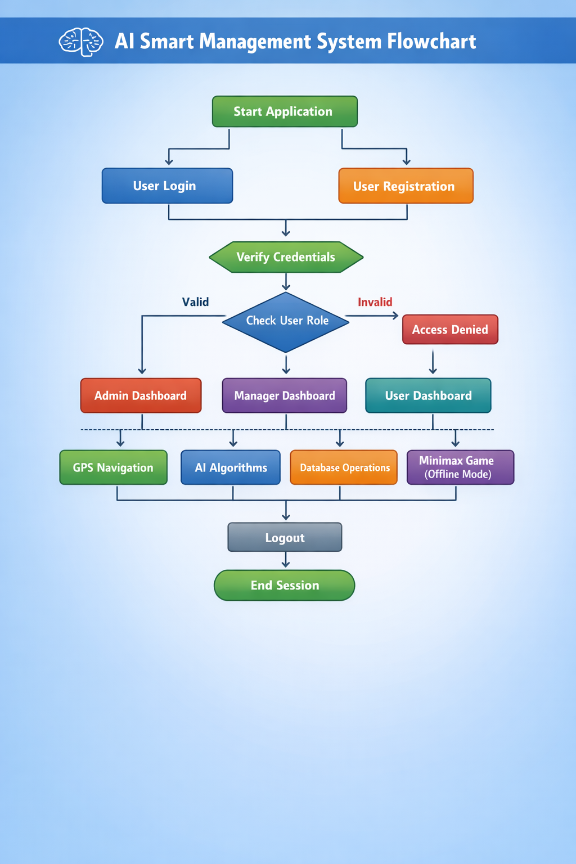
Output and screenshots

- Anaconda Navigation / jupyter Output

- Login Class

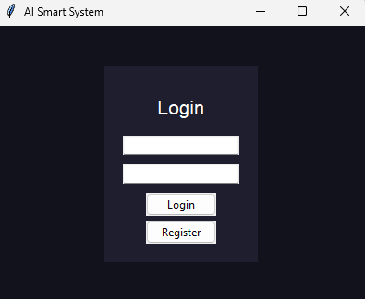

N 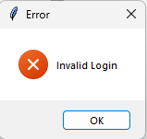

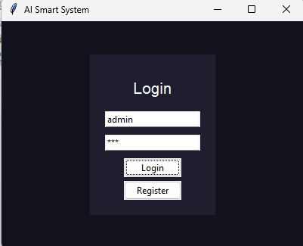

2. Registration Class:

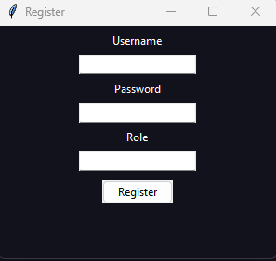

3.Admin Dashboard:

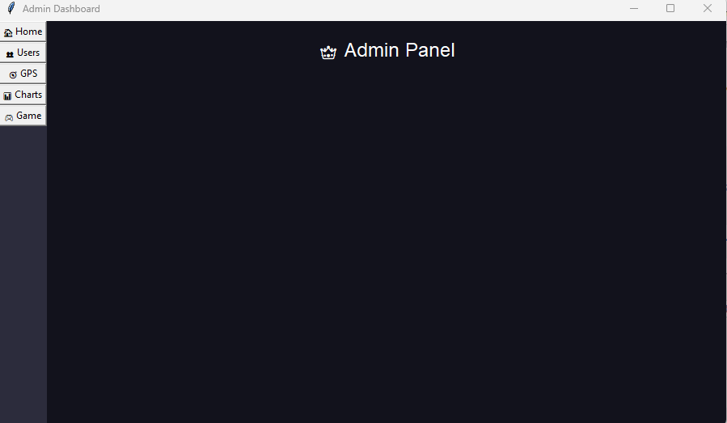
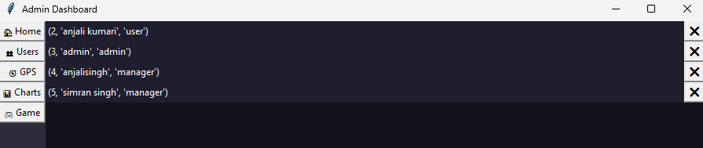

4.GPS Navigation :

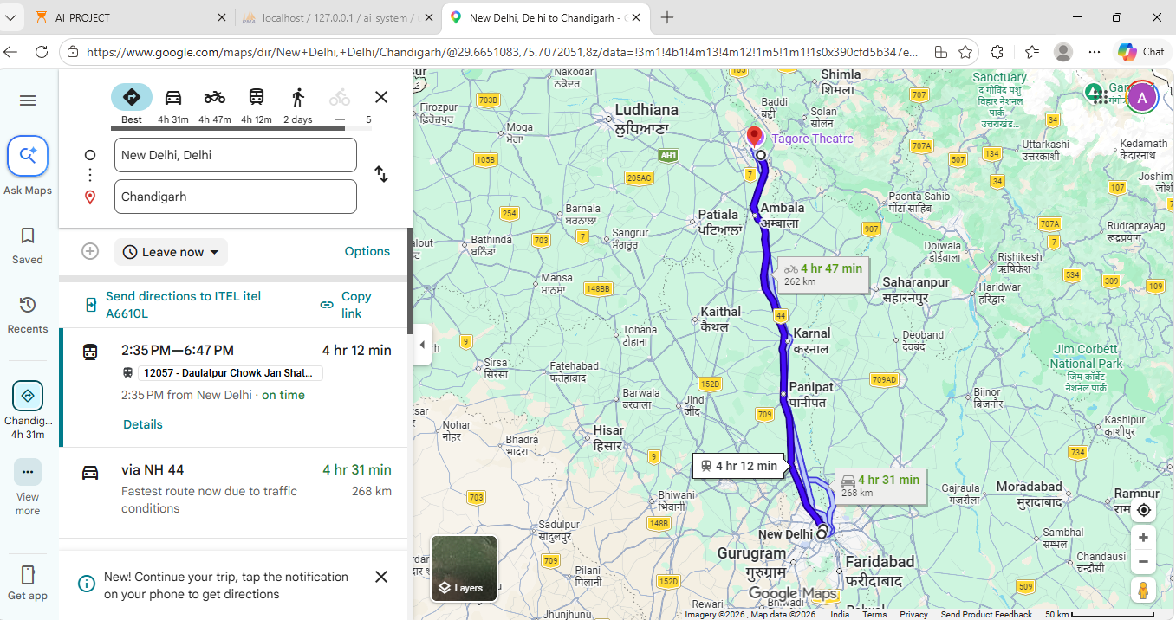

5.Game session after DB cut off:

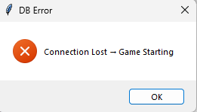



6.charts:
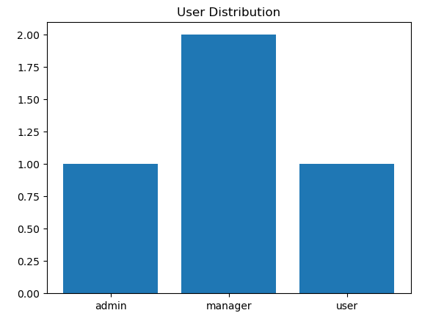

5.DATABASE CONNECTION :

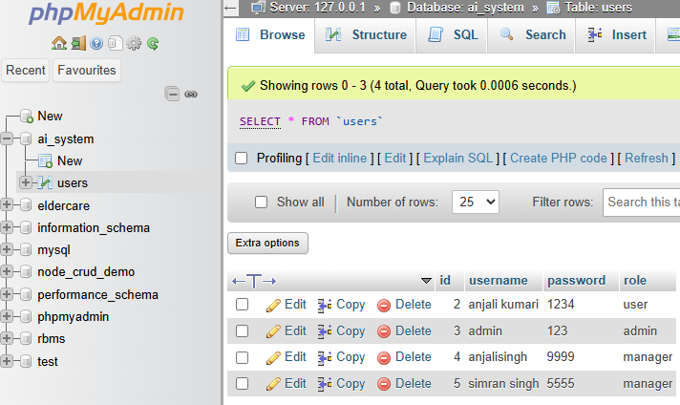

:

Future Enhancements
- Advanced Role Management
  - Add more roles like Super Admin, Manager, Guest
  - Improve access control for admin/user/game modules
- Improved Registration & Login
  - Add strong password validation
  - Email/OTP verification for secure signup
- Password Encryption
  - Use SHA-256 or bcrypt instead of plain text passwords
  - Improve database security
- Activity Logging System
  - Track login/logout history
  - Record user actions (navigation, admin operations, game usage)
- Enhanced AI Navigation System
  - Improve BFS, DFS, A*, Best First Search
  - Use real-time maps API and dynamic routing
- Game Module Upgrade
  - Add difficulty levels in Minimax game
  - Implement Alpha-Beta pruning
  - Add score tracking
- Better Data Visualization
  - Add pie charts and advanced analytics
  - Improve admin dashboard insights
- Cloud Database Integration
  - Move MySQL to AWS/Firebase/Azure
  - Enable remote access and scalability
- Web Application Version
  - Convert Tkinter system to Flask/Django
  - Make system accessible via browser

Conclusion
The AI Smart Router Management System developed in this project successfully integrates multiple intelligent features including user authentication, role-based access control, AI-based search algorithms, navigation system, and an interactive game module.
The system begins with a secure login mechanism where users authenticate using their username and password stored in a MySQL database. New users can register through the signup module, which allows secure credential storage and enables proper user management.
After login, users are redirected to role-based dashboards. The Admin dashboard provides functionalities such as user management, analytics visualization, navigation access, and game control, while normal users are granted limited and secure access to system features.
The system also implements multiple AI search algorithms such as BFS, DFS, A, and Best First Search* for pathfinding and navigation simulation. Additionally, the Minimax-based Tic-Tac-Toe game demonstrates artificial intelligence decision-making within the system.
Each module is designed using modular programming principles, ensuring better maintainability, scalability, and clarity. The project effectively demonstrates the integration of AI algorithms, database management, and GUI development using Tkinter.
In conclusion, the AI Smart Management System successfully achieves its objective of creating an intelligent, interactive, and role-based application. It provides a strong foundation for understanding real-world AI systems, database connectivity, and smart decision-making applications.

References

- www.github.com
- www.google.com
- www.youtube.com

Github link and Screenshot .

Link: https://github.com/anjalikumari21jsr-art/AI-smart-game-.git

